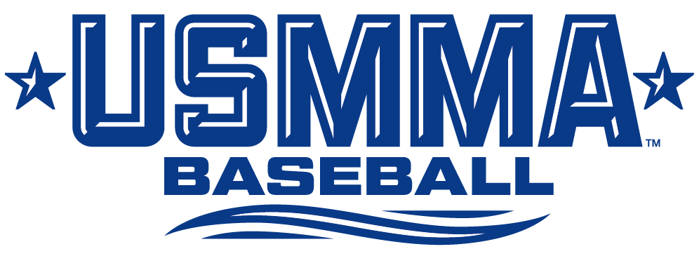
2026 USMMA Baseball Roster

# Name Yr. Pos. Ht. Wt. B/T Hometown/High School
1 Landon Troutt Jr. IF 5-8 160 L/R Fairfield, Calif. / Rodriguez
2 Jason Brown Fr. IF 5-11 165 R/R Marlton, N.J. / Cherokee
3 Charles Cahalan Sr. OF 5-11 185 R/R Overland Park, Kan. / Bishop Miege
4 David Cherwonuk Jr. P 6-1 210 R/L Chattanooga, Tenn. / The McCallie School
5 Luke Kruer So. P/OF 6-1 200 R/R Sellersburg, Ind. / Our Lady Of Providence
6 Tucker Bearden Fr. P/C 6-0 180 R/R Lakeland, Tenn. / Arlington
7 Quin Fitzgerald Jr. P 5-10 190 R/R Jupiter, Fla./ Jupiter Community
8 Davin Fulton Fr. IF 5-10 150 R/R Houston, Texas / Lutheran South Academy
10 Tommy Chiappetti Jr. P/OF 5-11 175 R/R Buckeye, Ariz. / Verrado
11 Baxter Hamilton Fr. LHP 6-2 180 L/L Sugar Land, Texas / Strake Jesuit College Prep
12 Parker Hutchins Sr. P 6-3 200 R/R Lucas, Texas / Lovejoy
13 Colton Holmes Fr. C 5-10 175 R/R Gurnee, Ill. / Warren Township
14 Louis Inserra So. IF 6-2 195 R/R Coplay, Pa. / Parkland
15 Drew Davis Fr. IF 6-2 185 R/R Springboro, Ohio / Springboro
16 Luke Sems Fr. RHP 6-5 200 R/R Oronoco, Minn. / Pine Island
17 Frank Ruepp Jr. OF 5-9 155 R/L Valdosta, Ga. / Lowndes
18 Christian Gamez Jr. UT 5-11 195 R/R Kent Island, Md. / Dematha Catholic
19 Michael Brown Fr. P/IF 5-11 190 R/R Dumfries, Va. / Charles J. Colgan Sr.
20 Eddie Lippert Sr. P 5-9 200 R/R Deer Park, N.Y. / Saint Anthony's
22 Levi Reale Fr. LHP 5-11 170 R/R Woodbridge, Va. / Saint John Paul The Great Catholic H.S.
23 Braden Vazquez So. IF 5-7 160 R/R Missouri City, Texas / Ridge Point
24 Carter O'Neel So. IF 5-10 165 L/R Omaha, Neb. / Elkhorn South
25 Gunnar Lyons Fr. OF 5-10 170 R/L Concord, Mass. / Concord Carlisle
26 Ryan Melton Fr. C 6-3 225 R/R Newnan, Ga. / Trinity Christian
28 Nathan Whitworth Fr. C 5-10 165 R/R Sierra Vista, Ariz. / Buena
29 Travis Campbell So. P 5'10 180 L/R Coleman, Texas/Alba-Golden High School
32 Thomas Byrne Fr. IF 5'10 175 R/R Mt Pleasant, S.C. / Lucy Beckham
33 Sullivan Dunn Fr. RHP 5'10 190 R/R Mendham, N.J. / West Morris Mendham
34 Caden Pierce Sr. P 6-6 200 R/R Marietta, Ga. / Lassiter
35 Ben Taylor So. IF 6-4 230 R/R Lexington, Ky. / Henry Clay
36 Axel Prechel Fr. OF 6-1 180 R/R Corvallis, Ore. / Corvallis
38 Kyle Hyland Fr. RHP 5-9 173 R/R Rockville Centre, N.Y. / Chaminade
39 Chris Viggiano Jr. P 5-9 165 L/L Seaford, N.Y. / Seaford
40 Jack Gibson So. C 5-4 155 R/R Danville, Pa. / Danville Area High School
43 Griffin King So. C 5-9 155 R/R Rockville Centre, N.Y. / Southside
44 Preston Longhurst Fr. OF 6-2 200 R/R Boerne, Texas / S.A. MacArthur
45 Ricardo Olivares Jr. OF 5-10 175 R/R Flower Mound, Texas / Flower Mound
51 Samuel Kim Jr. IF 6-2 215 R/R Mahwah, N.J. / Mahwah

Coaching Staff
Head Coach: Michael Notebaert (Ithaca ’03) – 18th Season as head coach (20th Overall)
Assistant Coach (Pitching Coach): Lou Bernardi (NYIT ’11) – Eighth Season
Volunteer Assistant Coaches: Chris Rodrigo, Edwin Rodriguez
Athletic Trainer: Daniel Unverzagt, MS, ATC, EMT (Lyndon State, '97) – 13th Season
Captains: #3 Charles Cahalan, #34 Caden Pierce

Pronunciations (BOLD CAPS indicates syllable emphasis)

#3 – CAL-uh-han (despite the spelling) #17 – ROOP HC – NOTE-ah-bart
#4 – Cher-WAN-nick #18 – GOM-mez AC – Ber-NAR-DEE
#5 – CREW-er #22 – REEL
#6 – BEAR-den #36 – PRECK-el
#10 – Chee-uh-PET-ee #39 – Vig-gee-AHN-oh (first syllable vig in “vigilante”)
#45 – Ahl-liv-AIR-iss (first two syllables is the word “olive”)

